**English Worksheet.**

**Unit I – Globalization and Communication.**

**Instrucciones – Instructions:**

**- Evite los borrones y el uso de corrector.**

**\* Avoid smudges or stains and the use of correction pen.**

**- Responda utilizando los espacios destinados dentro de la guía.**

**\* Use the suitable area to complete each activity.**

**- Utilice solo lápiz de pasta (azul/negro) o grafito.**

**\* Use pen (blue/black) o pencil.**

**HABILIDADES – SKILLS:**

**- Leer textos y reconocer nuevo vocabulario en ambos idiomas.**

**\* Read the texts and recognize the new vocabulary in both languages.**

**- Leer textos, analizar información y desarrollar las actividades.**

**\* Read the texts, analyse the info and complete the activities.**

**STUDENT : _________________________________________________.**

**GRADE: 2ND GRADE ________ DATE: ____________________________.**

**MISTER JUAN CARLOS JARA R. Score: __________ Mark: ____________**

**1.- Reading Comprehension. Read the texts on the next page and recognize the new vocabulary. Complete the chart below.**

**2.- Reading Comprehension. Read the texts again and complete the activities.**

|  |  |  |  |
| --- | --- | --- | --- |
| **ENGLISH** | **SPANISH** | **ENGLISH** | **SPANISH** |
|  |  |  |  |
|  |  |  |  |
|  |  |  |  |
|  |  |  |  |
|  |  |  |  |
|  |  |  |  |
|  |  |  |  |
|  |  |  |  |

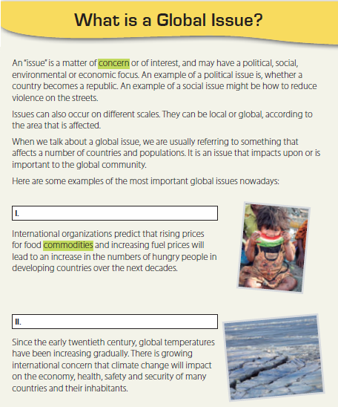

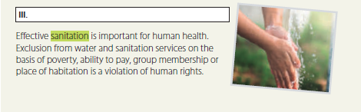

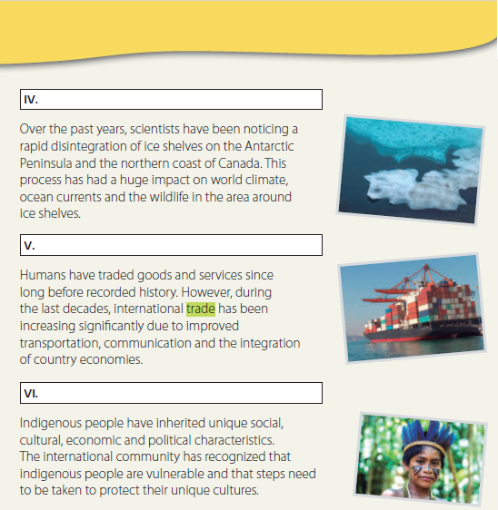

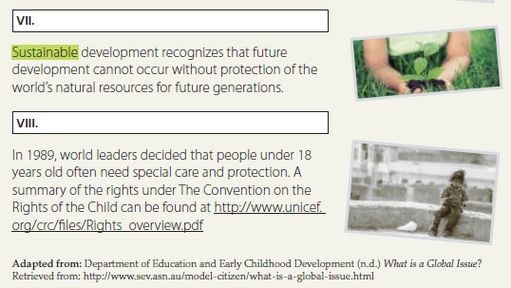

**1. Read the text carefully. Identify the subtitle (a – h) for each paragraph (I – VIII). Write on the bar. (8 points).**

a. Children’s rights b. Climate change

c. Global food production d. Globalization

e. Ice shelf boundaries f. Cultural diversity

g. Sustainability of the planet h. Water shortage

**2. Writing. Give Chilean examples of: (12 points)**

a. A political issue

_______________________________________________________________________________________________________________________________________________________________________________________________________________________________________________________________________________________________________________________________________

b. A social issue

_______________________________________________________________________________________________________________________________________________________________________________________________________________________________________________________________________________________________________________________________________

c. An environmental issue

_______________________________________________________________________________________________________________________________________________________________________________________________________________________________________________________________________________________________________________________________________

d. An economic issue

_______________________________________________________________________________________________________________________________________________________________________________________________________________________________________________________________________________________________________________________________________

**2. Rank the global issues in the text according to their impact on Chile (assign a number from 1 to 4, 1= the most important). (8 points)**

I.- ______ II.- ______ III.- ______ IV.- ______ V.- _____ VI.- ______

VII.- ______ VII.- _____